Details! Damage Meter Tutorial

AI Statement: ChatGPT was used to assist in determining which topics should be covered in this manual.

Utilizing the Details! Metering addon for World of Warcraft

Contents

Introduction and Credits 4

Details! Damage Meter 4

Getting Started 5

Downloading and Installing 5

Installing Using CurseForge App 5

Installing Manually 8

Enabling the AddOn 10

Window Control and Customization 14

Create a Window 14

Hiding a Window 15

Deleting a Window 16

Changing Wallpapers 19

Fonts 21

Changing Font Color 22

Changing Font Size 23

Changing Font Type 23

Recording and Reading Data 24

Capturing Data 24

Changing Displayed Data Metrics 25

Changing Displayed Segments 26

Broadcasting Results 27

Clearing/Deleting Data 28

# Introduction and Credits

## Details! Damage Meter

Details! Damage Meter is a popular customizable addon for World of Warcraft that provides detailed statistics about combat performance created by Tericob. It can track various metrics and statistics including damage dealt and healing done, commonly tracked as DPS (Damage Per Second) and HPS (Healing Per Second) respectively.

This introductory guide will show you the basics of how to use this addon. You will learn how to install the addon using an addon manager and how to install the addon manually. You will become familiar with managing the various metering windows, some customization, recording and reading data, and how to import and export profiles.

This tutorial assumes the reader has already installed World of Warcraft, and the game is launch-ready. This tutorial will cover basic features and will not delve into the more advanced features.

**Credits**: Details! Damage Meter is created and owned by Tericob. All images used in this manual is created by me. World of Warcraft is a game created by Blizzard Entertainment and is accessed with a monthly renewing license.

# Getting Started

## Downloading and Installing

### Installing Using CurseForge App

1. Navigate to CurseForge.com
2. Click “Get CurseForge App”

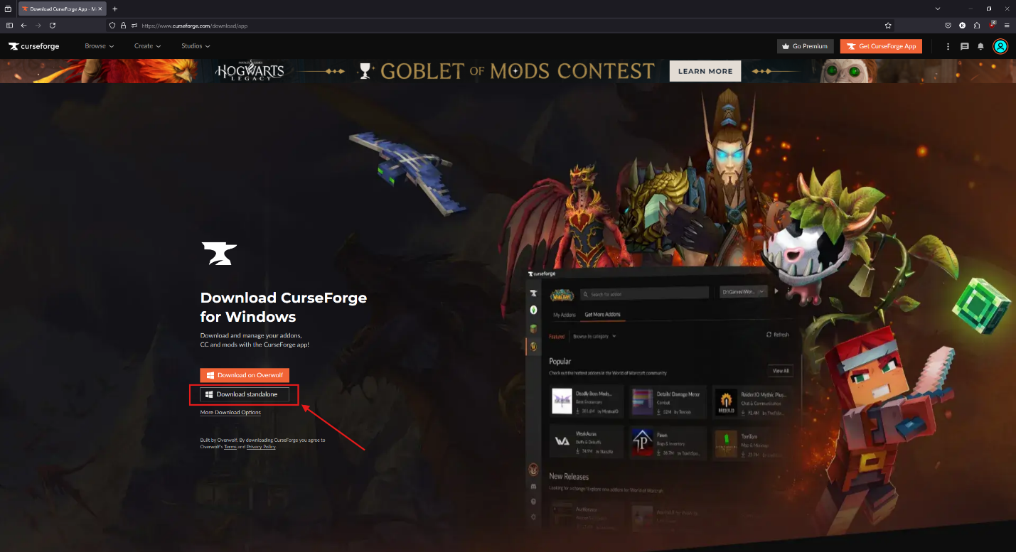

1. Click “Download Standalone”

Note: Your Operating System should 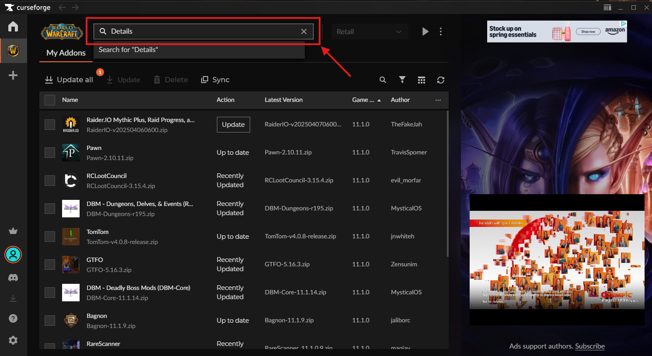 detected. If it is not, click “More Download Options” or scroll down to find your operating system’s installation file.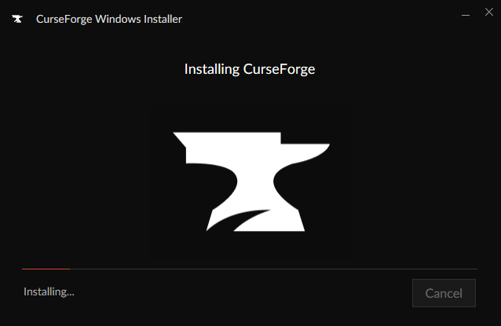

1. Run the downloaded installer to install the CurseForge App.
2. Launch the application if it does not automatically start.
3. In the search bar, type in “Details!” and press Enter. 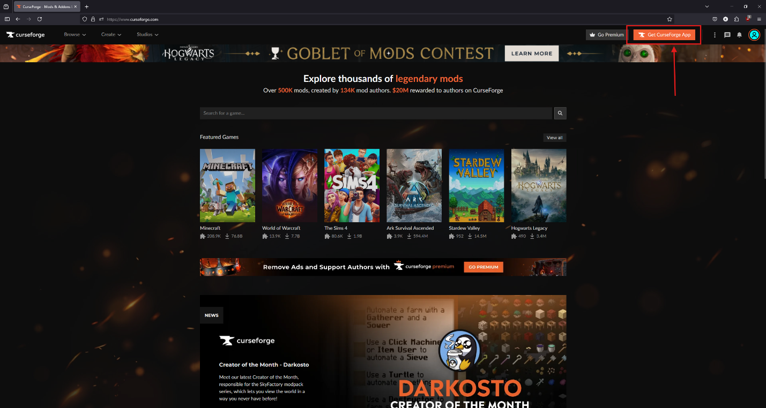
4. The first result should read, “Details! Damage Meter.” Click “Install” next to it and the application will download and install the addon automatically. 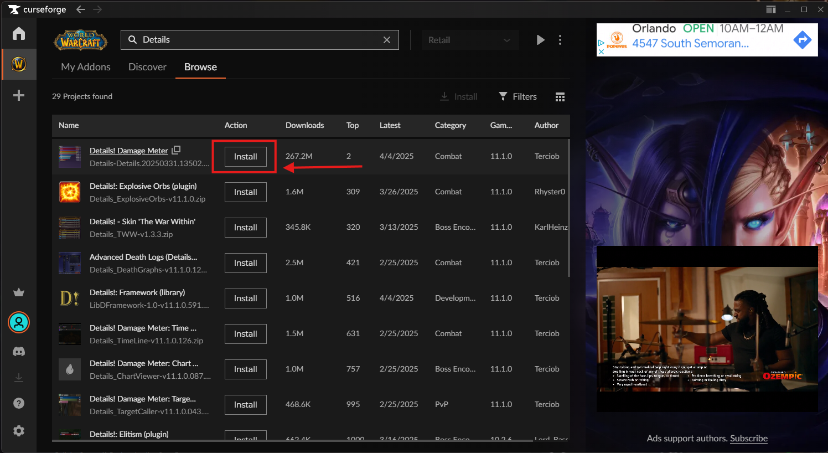

### Installing Manually

1. Navigate to CurseForge.com
2. Under “Featured Games,” select “World of Wacraft.” 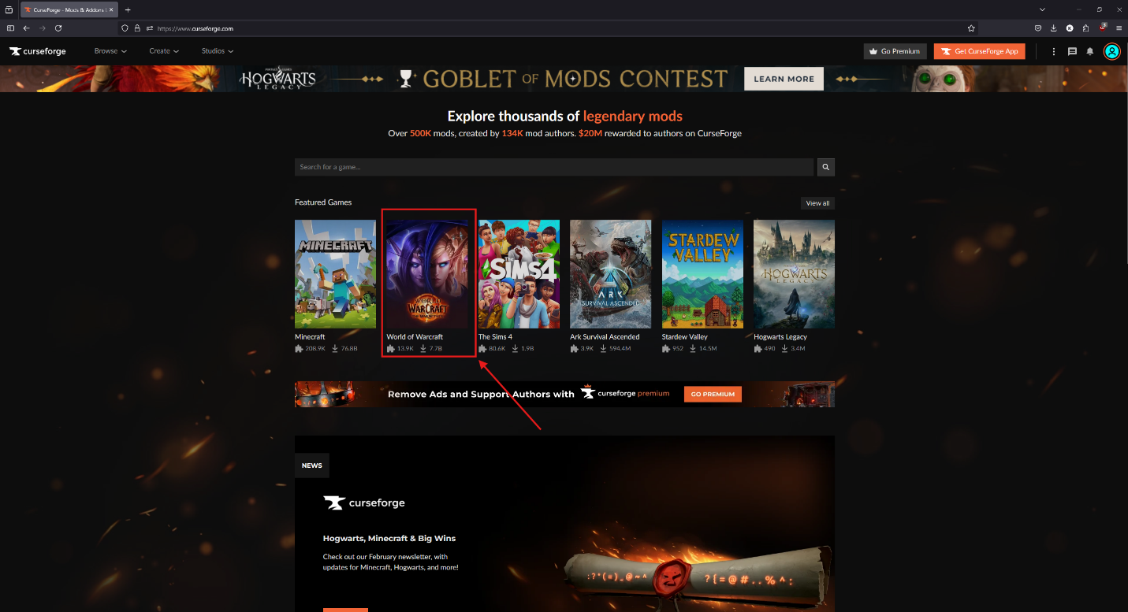
3. In the search bar, type “Details!” and press Enter.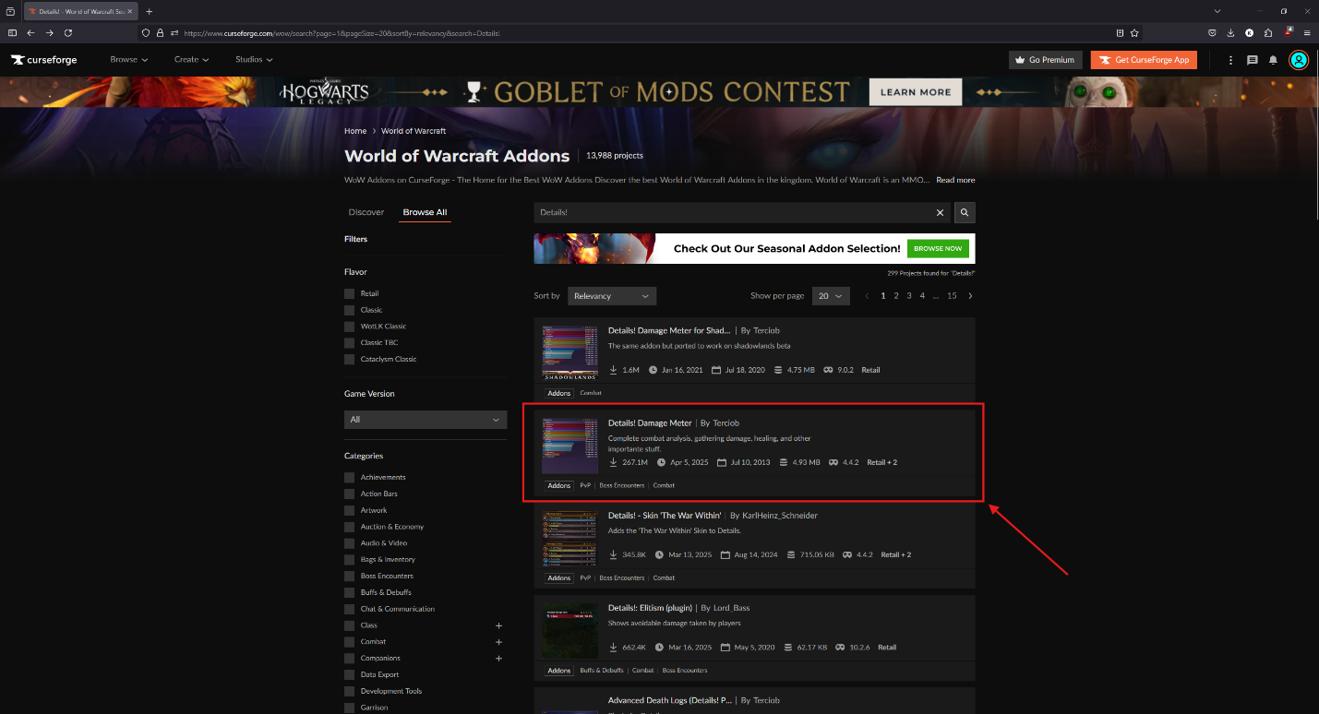
4. In the results, click the result named “Details! Damage Meter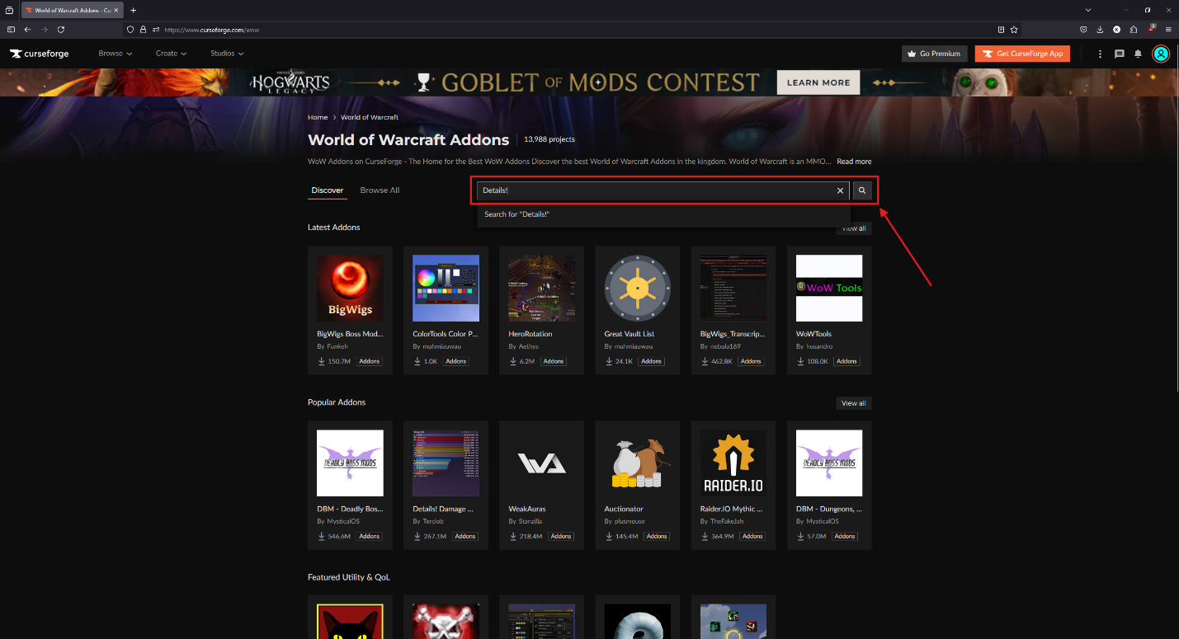
5. At the top of the page, click “Download” 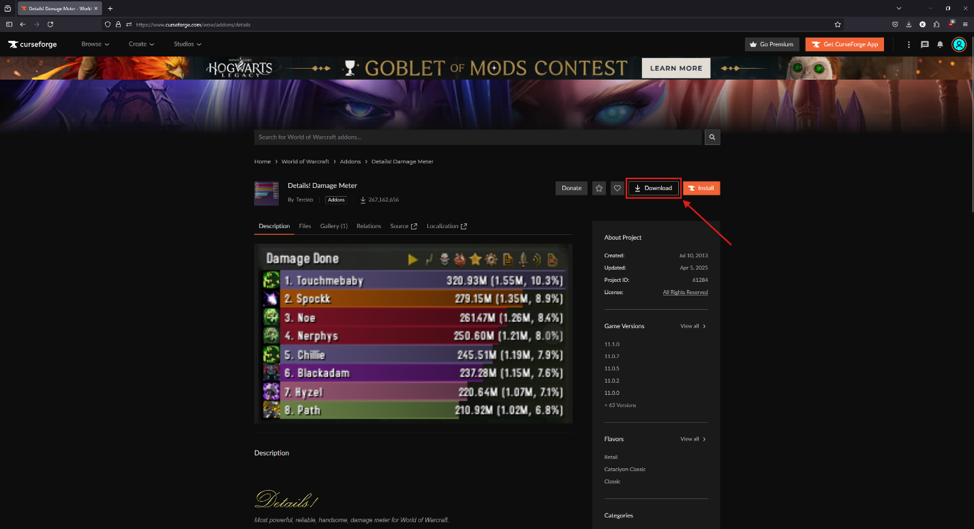
6. Open the downloaded zip file and copy all the folders. 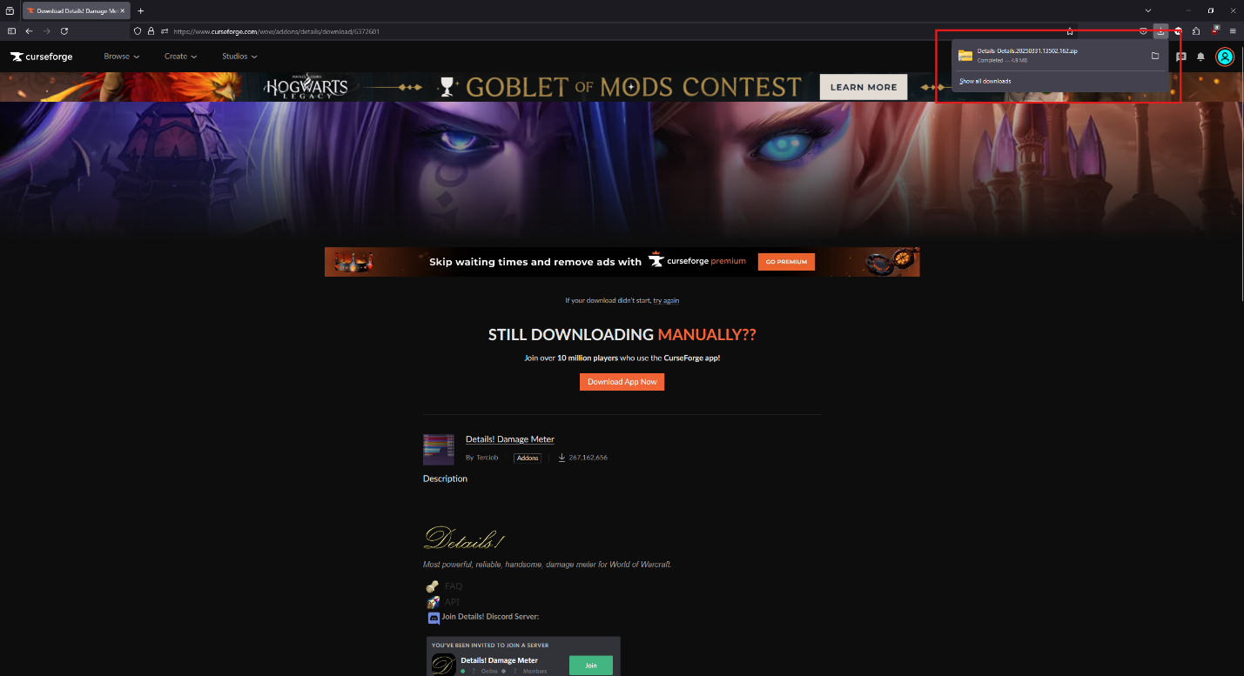
7. Navigate to where you installed World of Warcraft.
8. Navigate down the hierarchy:

World of Warcraft/_retail_/Interface/AddOns

1. Paste the copied folders into the AddOns folder

### Enabling the AddOn

1. Launch World of Warcraft normally
2. Login normally
3. At the character select screen, click “Menu” at the top of the screen to open the game menu. 
4. In the game menu, select “AddOns” 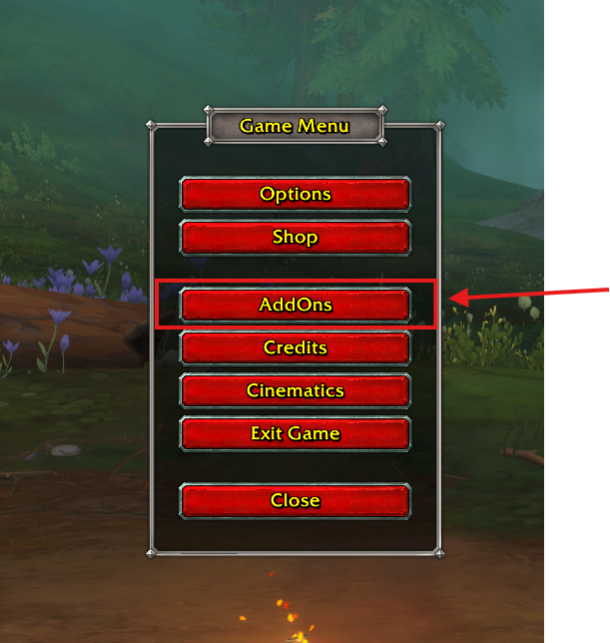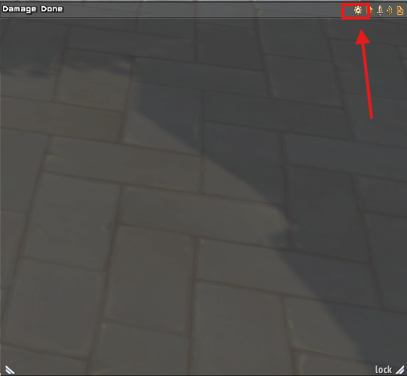
5. In the AddOns menu, scroll down until you find “Details! Damage Meter. Ensure the checkbox next to it, and all children, are checked. 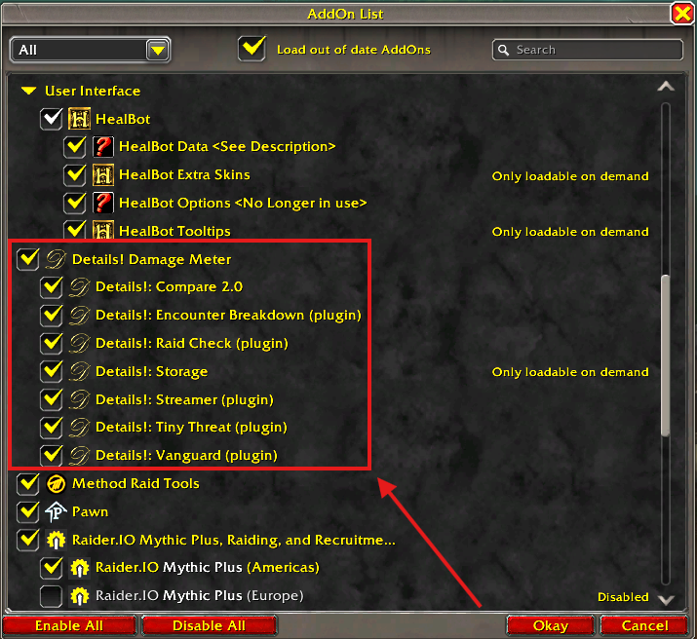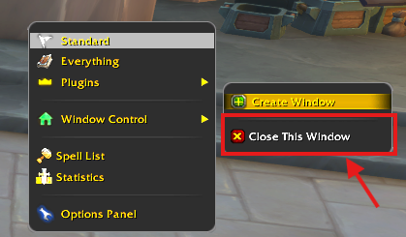

# Window Control and Customization

## Create a Window

1. Hover over the small cog in the Data Display box
2. Move the cursor to hover over “Window Control”
3. Select “Create Window” 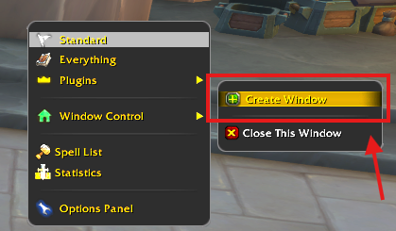

## Hiding a Window

1. Hover over the small cog in the Data Display box
2. Move the cursor to hover over “Window Control”
3. Select “Close This Window” 

## Deleting a Window

1. Left click the “Details!” icon located around the in-game mini map. Alternatively, you may left click the yellow cog at the top right of any Data Display box.
2. Under the “Tools” window, located at the far left of the new display window, select “Options” 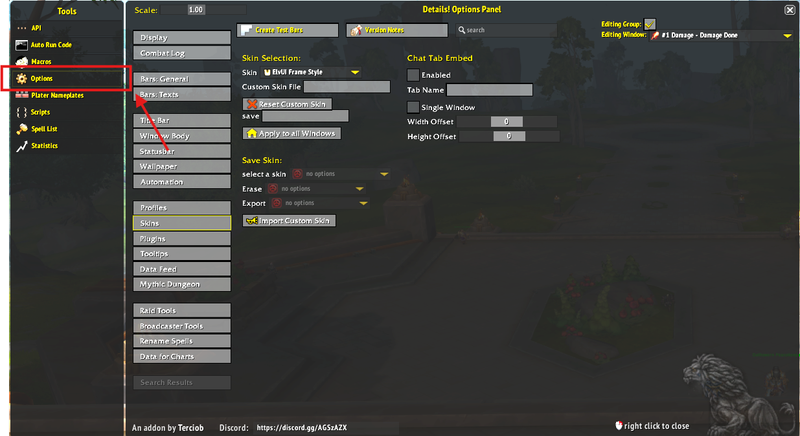
3. Select “Window Body” 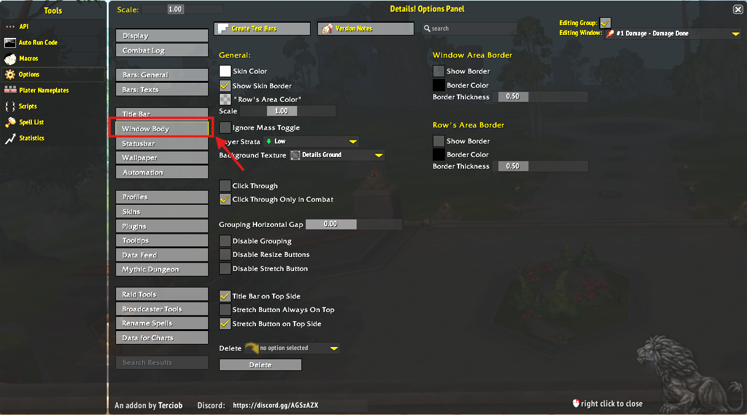
4. At the bottom of the window, in the drop-down menu labeled, “Delete,” select the window you want to remove. 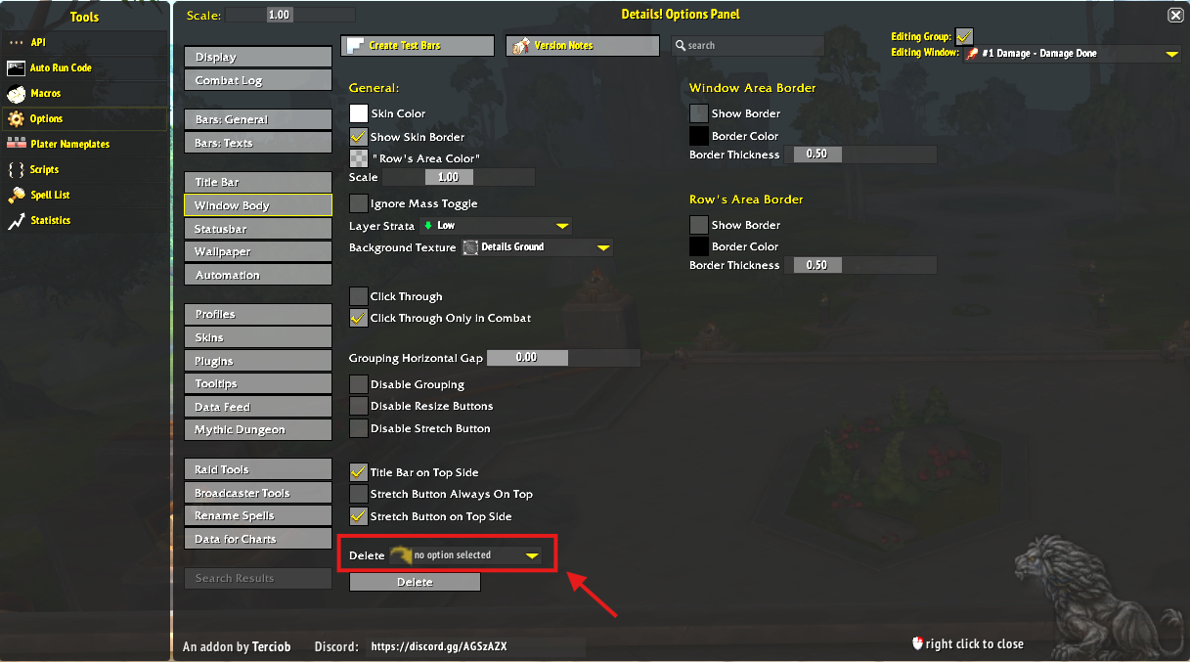
5. Press Delete. Your interface/game will reload. This is normal. 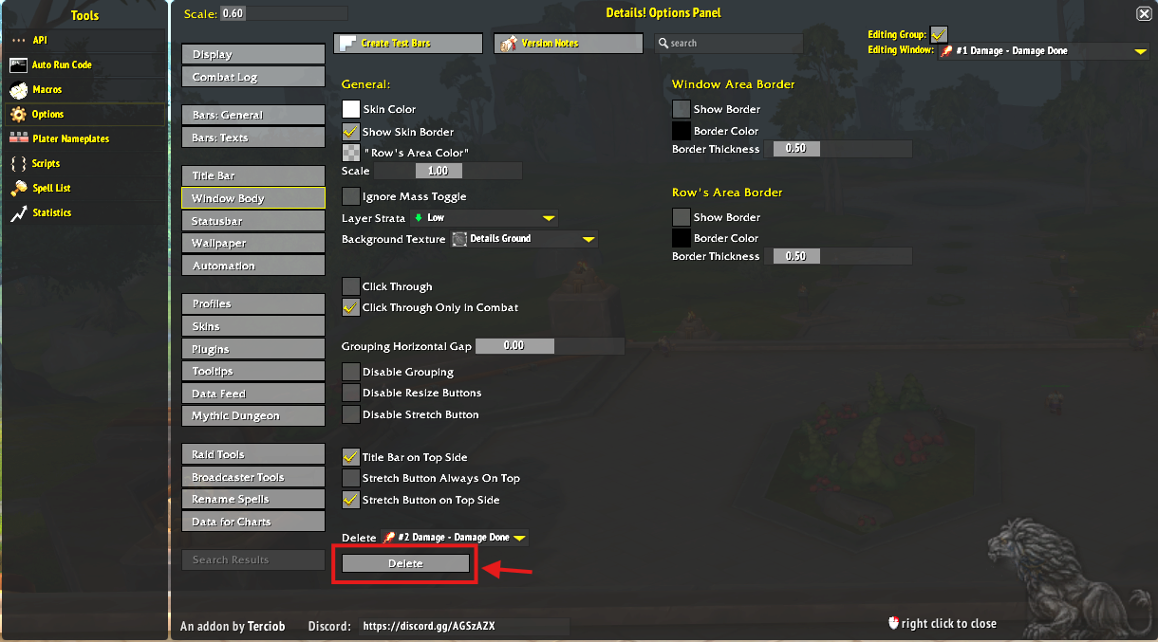

## Changing Wallpapers

1. Open the Options Panel by left clicking the Details! Icon located around the in-game mini map, or left clicking the yellow cog in a data display window. 
2. Under tools, select “Options” and then “Wallpaper.” 
3. Check the “Enabled” box at the top of the window. 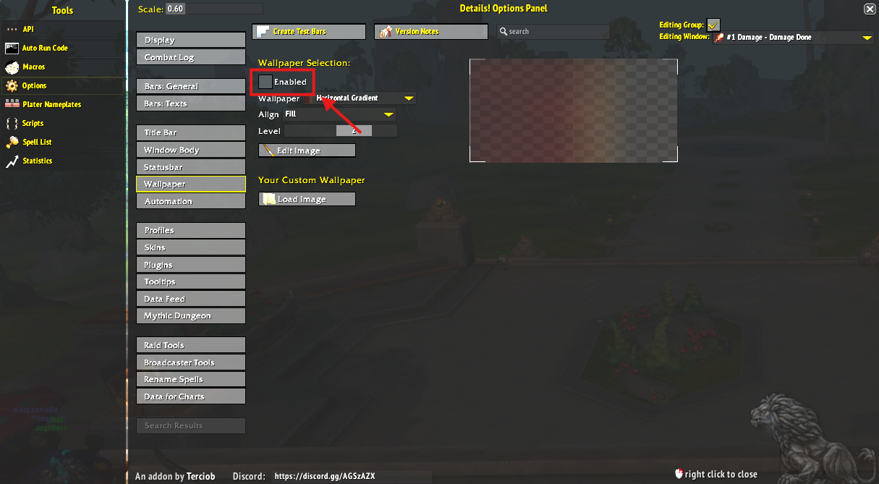
4. Select your wallpaper in the dropdown menu. 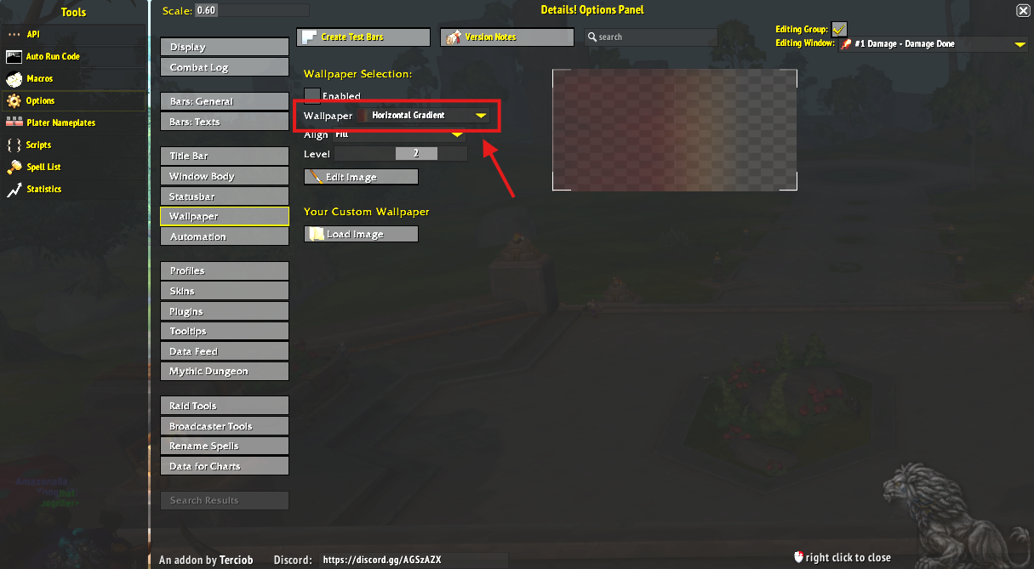

## Fonts

1. Open the Details! Options Panel by left clicking on the Details! Icon located around the in-game mini map, or left clicking on the yellow cog in a data display window.
2. Under tools, select “Options” and then “Bars: Text.” This window will allow you to modify the various aspects of the text for that appears in the data display windows. 

### Changing Font Color

1. In the Bars: Text window, under general, left click the color swatch box next to “Text Color.” This will open up a Color Picker Window. 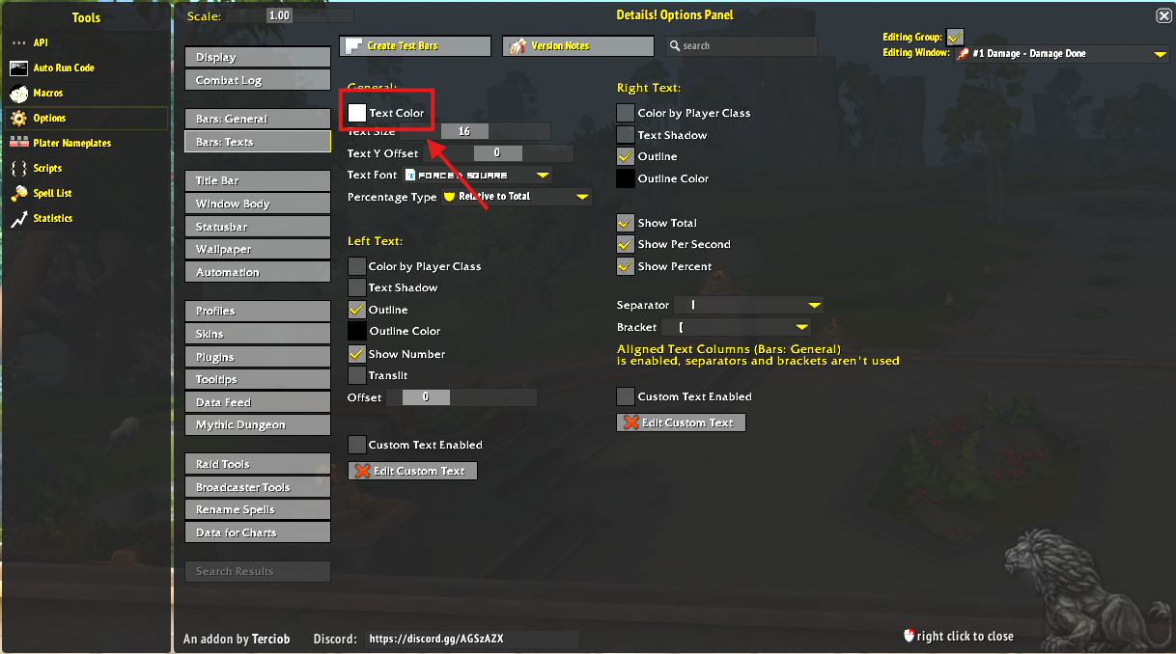
2. In this window, you use the wheel to select your desired color, input a hexadecimal color code, or RGB values between 0-255. 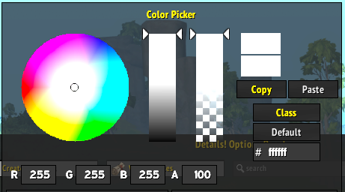

### Changing Font Size

1. In the Bars: Text window, under general, move the sliding bar next to, “Text Size.” Or, while hovering over the sliding bar, press the plus(+) or minus(-) button to incrementally change the font size. 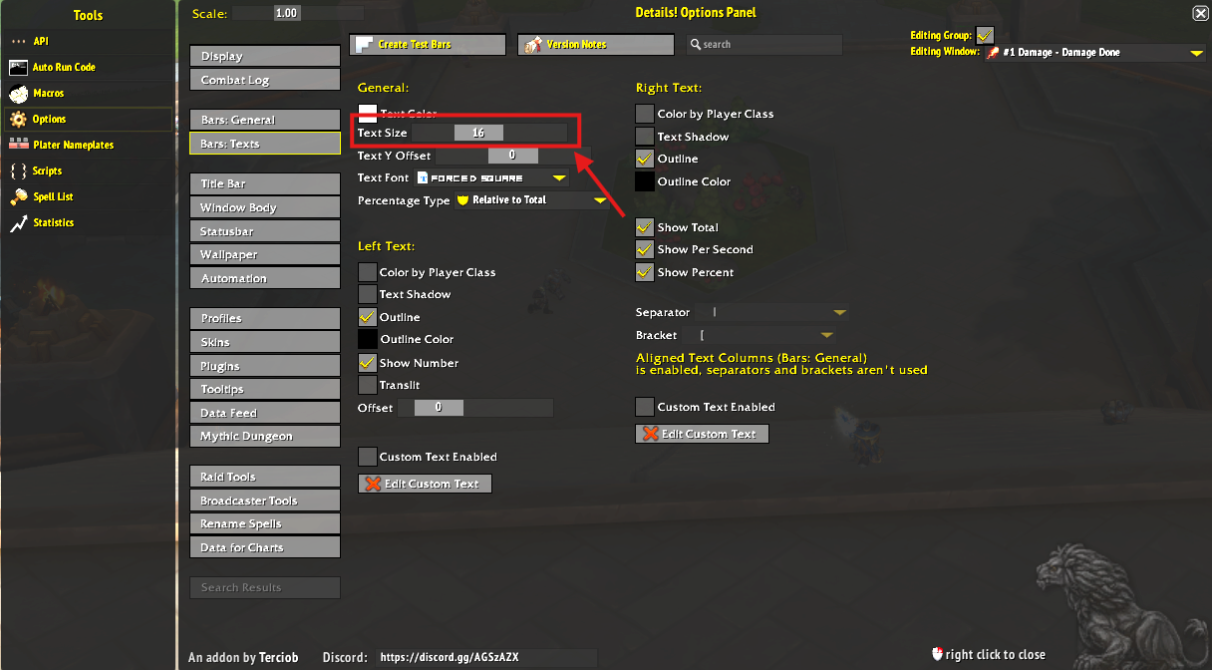

### Changing Font Type

1. In the Bars: Text window, under general, expand the drop down menu next to, “Text Font,” to display a list of different fonts.
2. Select the font you want to change the text to. 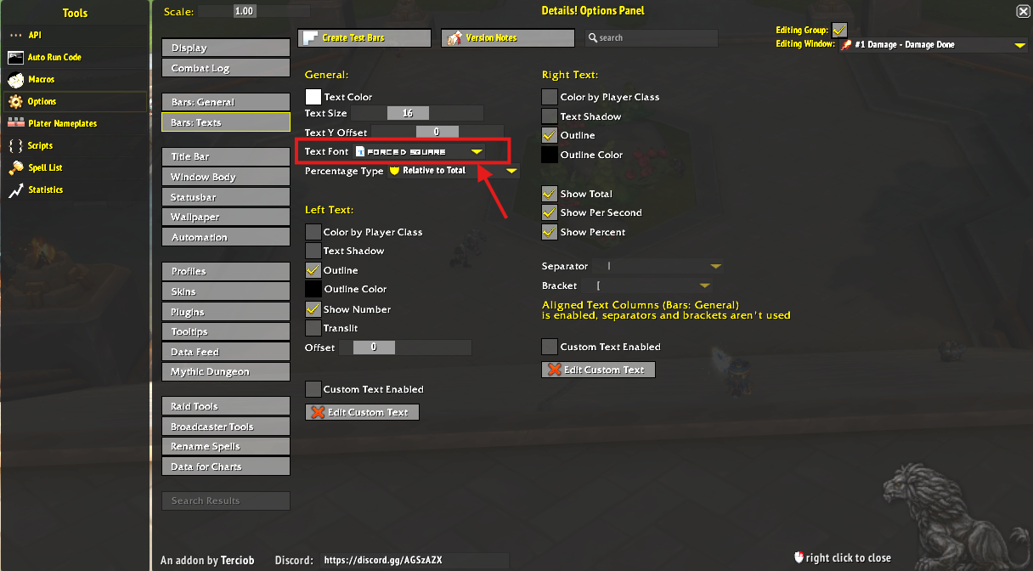

# Recording and Reading Data

## Capturing Data

1. To begin capturing data, hold the CTRL key and left click on the Details! Icon located around the in-game mini map. This will open the data display window. If the window is already open, skip this step. 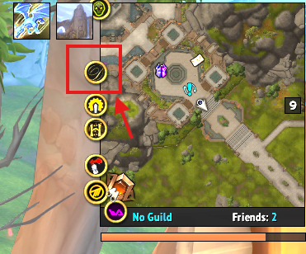
2. During combat, Details! will automatically capture combat data and display it in the data box. 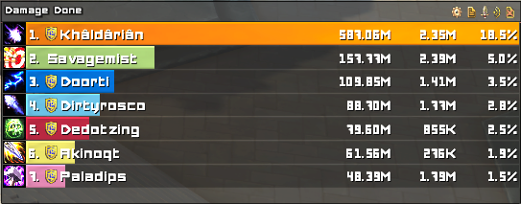

## Changing Displayed Data Metrics

1. In the data display box, hover over the sword icon. This will display a menu where you can change what metrics are displayed as well as sub-categories such as damage taken and over healing done. 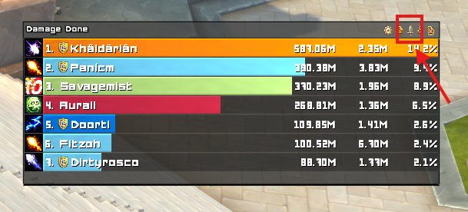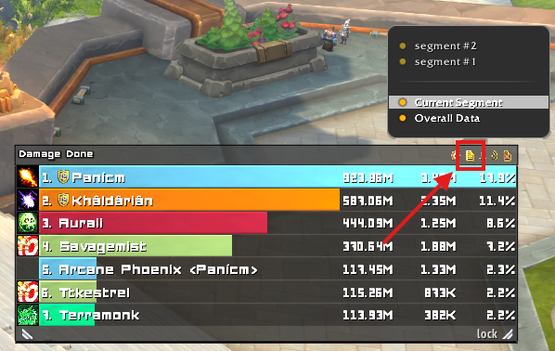

## Changing Displayed Segments

1. In the data display box, hover over the document icon. This will display a window displaying all currently saved segments.
2. Select the segment you’d like to view. You may also change the data metrics displayed when viewing a previous segment. Refer to, “Changing Displayed Data Metrics,” above on how to do this. 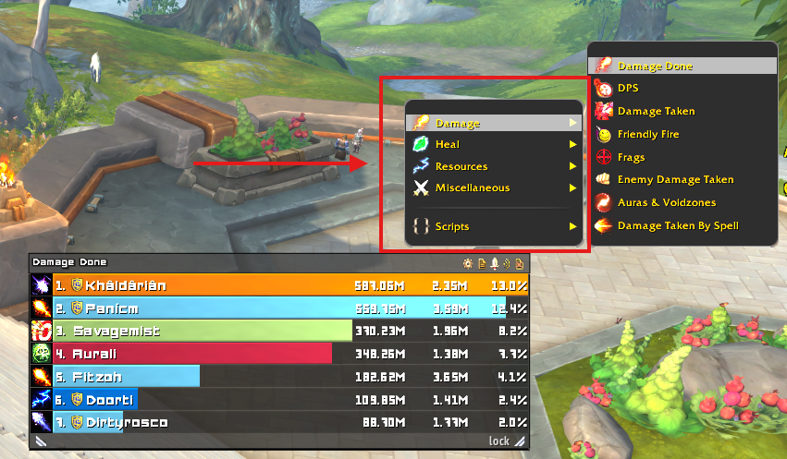

## Broadcasting Results

1. In the data display box, left click the broadcast icon. This will open the, “Link Details!,” window.
2. In the Link Details! window, expand the drop-down menu to display different broadcast targets. This can be whispered to another player, sent to a party or raid group, or to your guild. You can also set how many lines of data are sent by sliding the “Lines,” bar. 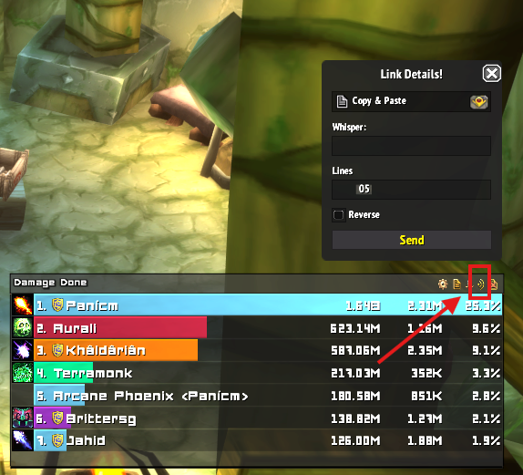
3. Once you preferences are set, left click the “Send,” button, and it will automatically send the data to the in-game chat system.

## Clearing/Deleting Data

1. In the data display box, hover over the delete icon. This will display several options for deleting data.
2. Selecting “Reset All Data,” will erase ALL data since the beginning of recording. 